Definitions:
- Biotechnology
  - Application of living organisms, cells, or biological processes to develop products and technologies that benefit human life and the health of the planet.
  - Essentially merges biology with technology to solve problems across various fields, including medicine.
- Artificial Intelligence (AI)
  - Branch of computer science focused on building machines capable of performing tasks that typically require human intelligence, such as learning, reasoning, problem-solving, perception, and understanding language. (Basically, human perception but in technology.)
- Cyber Technology
  - Collection of tools, skills, and processes used to operate in and manage the interconnected digital environment known as cyberspace.
  - Networks (like the internet), communication systems, and the data processed within them.
Real World Considerations:

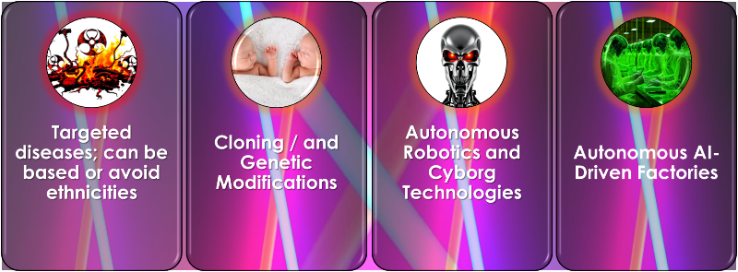
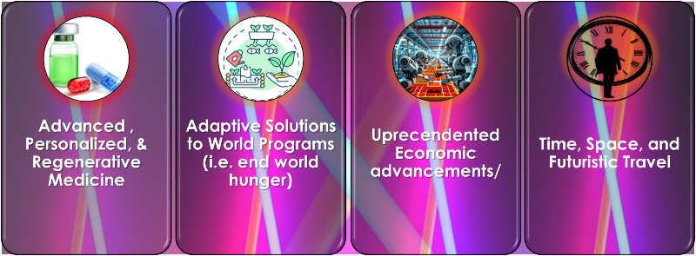
Positive Aspects of Convergent Tech | Negative Aspects of Convergent Tech

